**CHAPTER 1**

**INTRODUCTION**

1. **Introduction**

Video processing is widely used in many areas such as health, city planning, auto industry, space and military where accurate image frames are required. For instance, in a surgical operation where cameras are used, the operator needs real time video which is stable to understand the correct location of the problem. In a military system where object tracking is used, consecutive frames should be stable in the spatial domain, so that tracking algorithm can work properly.

Video stabilization is a technique which is used by many different fields in today’s world to achieve a stable video sequence from a shaky video. Medicine, military and robotics are three main fields in which video stabilization is heavily used. For example, in endoscopy and colonoscopy videos need to be stabilized to determine the exact location and width of the problem. Videos captured by aerial vehicles on a reconnaissance flight need to be stabilized for localization, navigation, target tracking, etc. Furthermore utilization of digital cameras has always been popular and hence video stabilization has entered our daily life with the aim of removing shaky motions from videos captured by non-professional users. Different approaches to stabilize shaky videos as follows.

1. **Different Approaches to Video Stabilization**

There are mainly three different approaches to stabilize a shaky video. These include mechanical, optical and digital stabilization methods. In this section each approach is briefly discussed.

**1.2.1. Mechanical Video Stabilization Technique**

Mechanical image stabilization systems using the vibration feedback of the camera which is detected via special sensors like gyros accelerometers etc. are the earliest developed stabilization techniques. In mechanical methods, accelerometer and

gyros sensors are used for motion detection and then the camera is moved against the movement direction. Figure 1.1 demonstrates a camera with mechanical stabilizer where a gyroscope is attached to the camera.

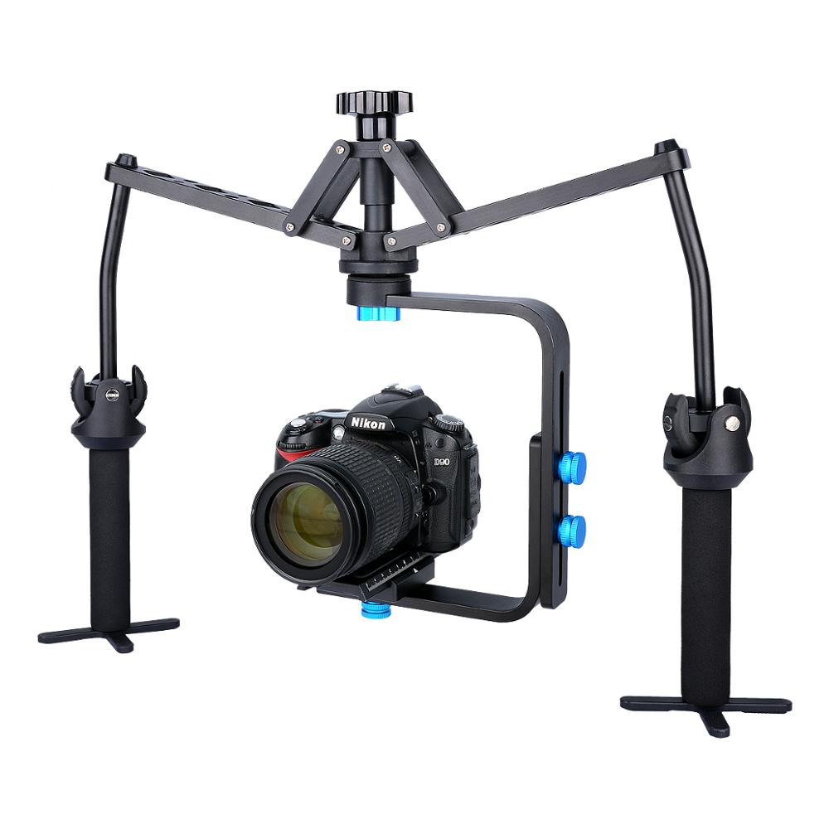

Figure 1.1 Camera with Mechanical Stabilizer

**1.2.2. Optical Video Stabilization Technique**

Optical stabilization techniques are developed few years after mechanical techniques. If instead of moving the whole camera just the pieces of the lens glass move, the stabilization technique is referred to as optical stabilization which is the most effective one and employs a moveable lens assembly that variably adjusts the path length of the light as it travels through the camera’s lens system. In this technique angle and speed of the camera shake is detected by two gyro sensors. According to the movement direction of the entire lens, the select lens elements should be moved so the image passing through the lens can be steady and sharp when it hits the imaging sensor. Figure 1.2 illustrates the function of optical image stabilizer when the lens is jerked downward. Due to the downward movement of the camera the center of the image moves downward on the focal plane. Shifting the optical Image Stabilizer lens group downward, the light rays are refracted so that the image center returns to the center of the focal plane.

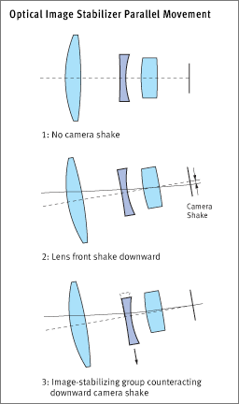

Figure 1.2 Optical Image Stabilizer Parallel Movement

**1.2.3. Digital Video Stabilization Technique**

Digital video stabilization adopted by many companies for their products, is the least expensive and precise solution to remove unwanted motions from captured videos. In general, stabilizing a video by digital algorithms contains three main steps including motion estimation, motion smoothing and image composition. The transformation parameters between two consecutive frames are derived in the first stage. The second stage filters out the unwanted motion and in the last stage the stabilized video will be reconstructed. In all video stabilization algorithms motion Estimation is the most important part which describes the transformation from one video frame to the subsequent one.

1. **Motivation**

Shaky video can be occurred when recording video by many effects of motions. This shaky video is disturbing to the viewer. To make high quality video with a hand handle camera is a very difficult task. The unwanted movements of our typically blur and disturbing jerkiness in the recorded video. Moreover this problem is amplified when a zoom lens or a digital zoom is used. To solve this problem many video stabilization technique have been developed. Digital video stabilization technique make use only of information drawn from images and do not need any additional hardware tools. So, digital video stabilization using point feature matching technique had been chosen to analysis in this thesis.

1. **Problem Statements**

To implement digital video stabilization on FPGA, there are many problems and limitations of hardware and software services. Hardware limitation has been occurred when choosing FPGA board and their accessories such as analog to digital converter (ADC), video input interface and display interface. On the other hand, software problems, skill and developing of logic level programming and concurrent programming knowledge are established as major problems.

So, PYNQ, the Xilinx® Zynq® All Programmable device, which is an SOC based on a dual-core ARM® Cortex®-A9 processor, is used to solve the hardware limitations and software problems. The SOC of A9 processor can compile high level programming to machine language by using overlays and there is no extra hardware needed to mounted at the board because the input and output ports are available in that board as build in plug and play accessories.

1. **Aim and Objectives**

This thesis gives real-time video stabilization approach for small and mobile equipment. The aim of digital video stabilization is to remove unwanted movements, undesirable shakiness, blur and poor quality video.

The main objectives of this thesis are:

1. To introduce the basic concept of digital video stabilization
2. To study the point feature technique.
3. To know the nature and architecture of FPGA.
4. To be familiar with programming languages for FPGA
5. To be touch with Python and C++ programming languages
6. **Scope of Thesis**

In this study, digital video stabilization methods using point feature matching technique will be explained. Algorithms of this technique are also explained with examples. And this technique will be implemented on Field Programmable Gate Array.

1. **Outlines of Thesis**

This thesis is constructed with the following structures,

1. Chapter one initiates the introduction of this thesis. Aims, Objectives, Scope and Outlines of thesis are also described.
2. Chapter two is about literature review where include digital video stabilization and Field Programmable Gate Array architecture.
3. Chapter three discusses for digital video stabilization using point feature matching technique.
4. Chapter four implements digital video stabilization on FPGA and MATLAB.
5. Chapter five is the simulation results and comparison of MATLAB and FPGA results.
6. Chapter six represents conclusion and future work in this thesis.